Q3: Write a Spark command to read a CSV file located at "data/source.csv", ensuring the first row is treated as a header and inferSchema is enabled.
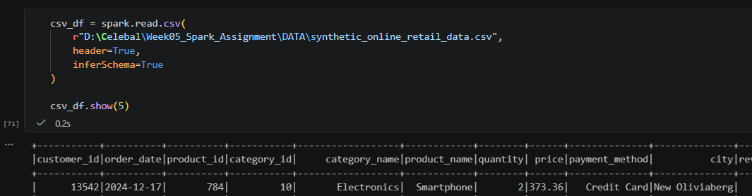

Q5: Given a DataFrame df, write a query to select the columns product_id and price where the category is 'Electronics'.
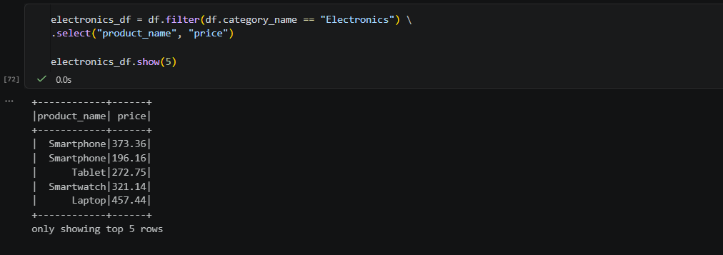

Q6: Write the code to "revise" a DataFrame by renaming the column old_name to new_name and casting the price column from a String to a Double.
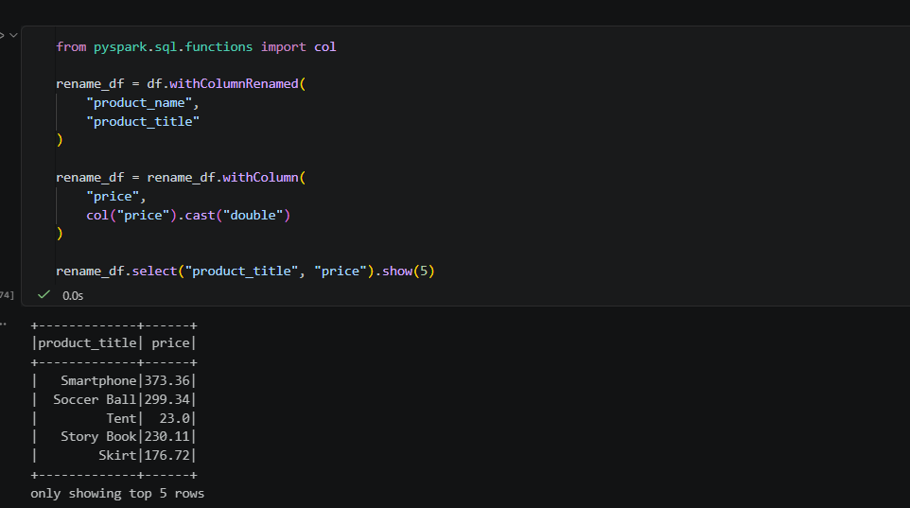

Q8: Write a query to filter a DataFrame df_orders for rows where the status is 'Completed' AND the amount is greater than 1000.
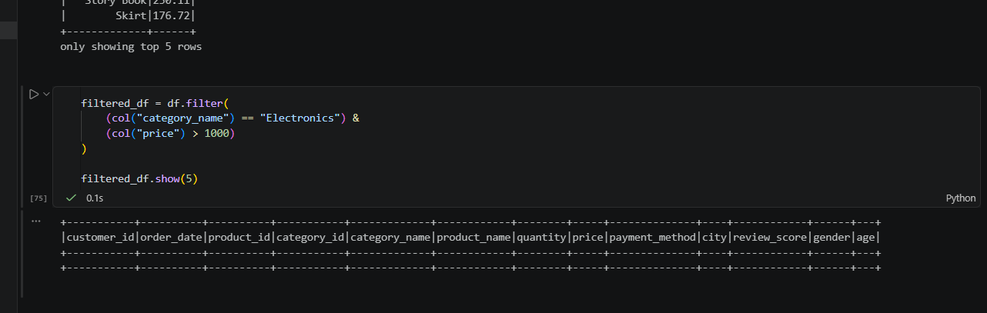

Q10: Write a code snippet to add a new column final_price which is the base_price multiplied by 1.18 (18% tax).
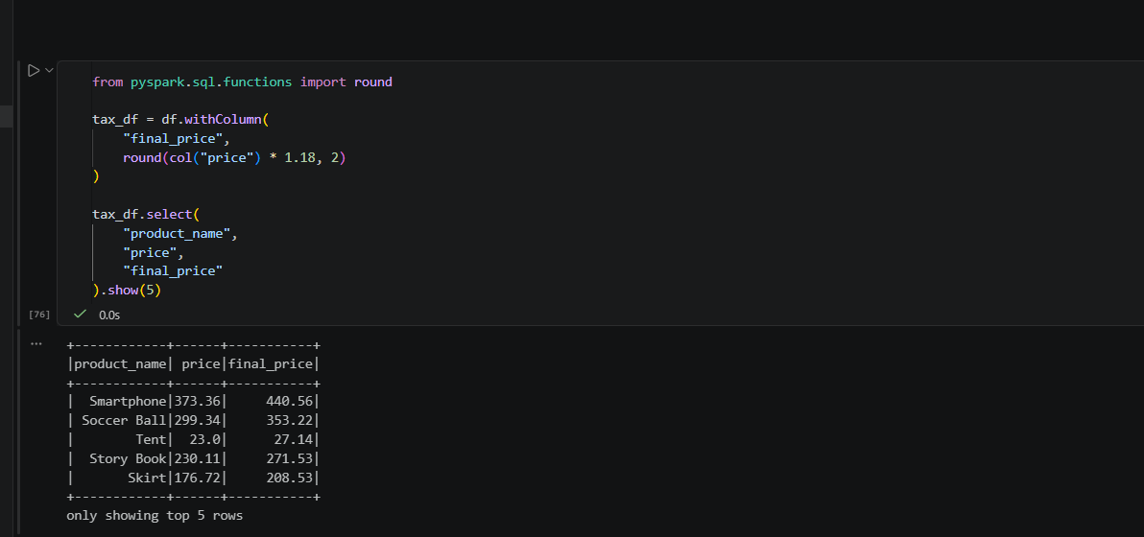

Q12: Write the Spark command to load a Parquet file from "path/to/input", filter out any rows where user_id is null, and save the result as a CSV at "path/to/output".
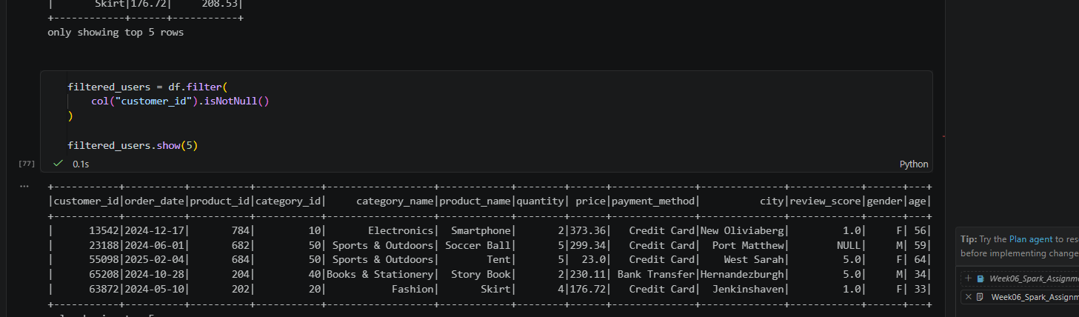

Q14: Write a query to filter a dataset for rows where the region is 'North' OR the priority is 'High'.
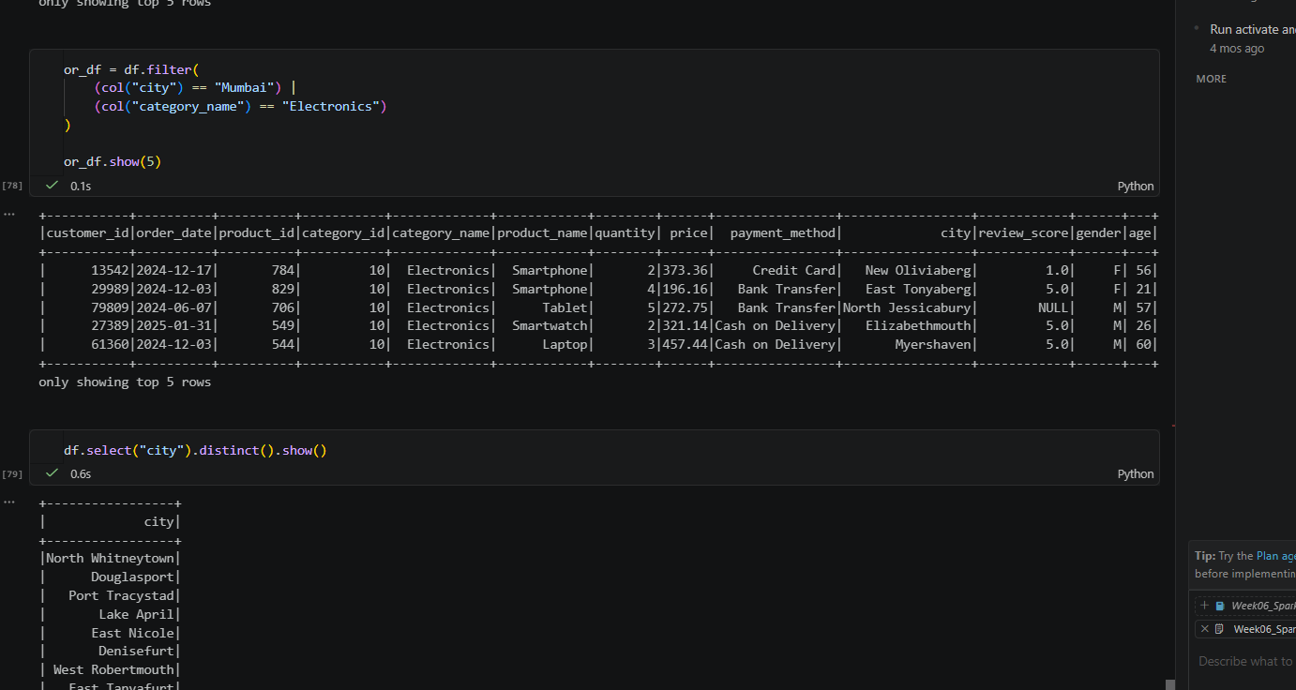
Q1. Explain the roles of the Driver, Cluster Manager, and Executor in a Spark application.
Apache Spark follows a distributed computing architecture consisting of three main components:
Driver: The Driver is the main program that creates the SparkSession, converts user code into execution tasks, builds the Directed Acyclic Graph (DAG), schedules tasks, and collects results from Executors.
Cluster Manager: The Cluster Manager manages cluster resources by allocating CPU and memory to Spark applications and launching Executor processes on worker nodes.
Executor: Executors are worker processes responsible for executing tasks assigned by the Driver, processing data partitions, storing intermediate results, and sending the final results back to the Driver.

Q2. How does Spark's Lazy Evaluation strategy improve performance when chain-
Spark uses Lazy Evaluation, which means transformations such as filter(), select(), and withColumn() are not executed immediately. Instead, Spark records these operations in a Directed Acyclic Graph (DAG). When an action such as show() or count() is called, Spark optimizes the entire execution plan and executes all transformations together. This minimizes unnecessary computations, reduces data movement, and improves overall processing performance.
Q4. What is the difference between CSV and Parquet in terms of storage and why does it matter for performance?
CSV | Parquet
Row-based storage | Columnar storage
Larger file size | Smaller file size
Slower query performance | Faster query performance
No built-in compression | Supports compression
Reads the entire row | Reads only required columns
Why it matters:
Parquet improves Spark performance because it stores data in a columnar format, allowing Spark to read only the required columns. This reduces disk I/O, memory usage, and processing time, making Parquet more efficient than CSV for analytical workloads.
Q7. How does Spark use the Lineage Graph (DAG) to provide fault tolerance if a worker node fails?
Spark maintains a Lineage Graph (DAG) that records every transformation applied to a dataset. If a worker node or Executor fails, Spark uses the DAG to recompute only the lost partitions instead of processing the entire dataset again. This provides efficient fault tolerance and reduces recovery time without requiring full data replication.
Q9. Explain the concept of Predicate Pushdown in Parquet and how it affects the amount of data loaded into memory.
Predicate Pushdown is an optimization technique supported by Parquet. When a filter condition is applied, Spark pushes the filter to the storage layer so that only the required rows are read. Instead of loading the entire dataset into memory, only the matching records are loaded. This significantly reduces disk I/O, memory consumption, and query execution time.
Q11. What is the difference between Transformations and Actions? Provide two examples of each.
Transformations | Actions
Lazy operations | Trigger execution
Return a new DataFrame | Return results or write data
Do not execute immediately | Execute the DAG
Examples of Transformations:
filter()
select()
Examples of Actions:
show()
count()

Q13. In Spark Architecture, what is the difference between Client Mode and Cluster Mode?
Client Mode | Cluster Mode
Driver runs on the client machine. | Driver runs inside the cluster.
Suitable for development and testing. | Suitable for production environments.
Application stops if the client disconnects. | Application continues even if the client disconnects.

Q15. When exploring a dataset, why is it safer to use .show(5) instead of .collect() on a multi-terabyte dataset?
The show(5) method displays only the first five rows of a dataset without loading all the data into the Driver's memory. In contrast, collect() retrieves the entire dataset and stores it in the Driver's memory. For very large datasets, using collect() can lead to excessive memory usage, slow performance, or application failure. Therefore, show(5) is the recommended approach for safely exploring large datasets.

